Name: Umamah Binti Aziz
SAP ID: 72012
Dept: BSCY-03
COAL LAB
LAB 10 TASKS
Task 01
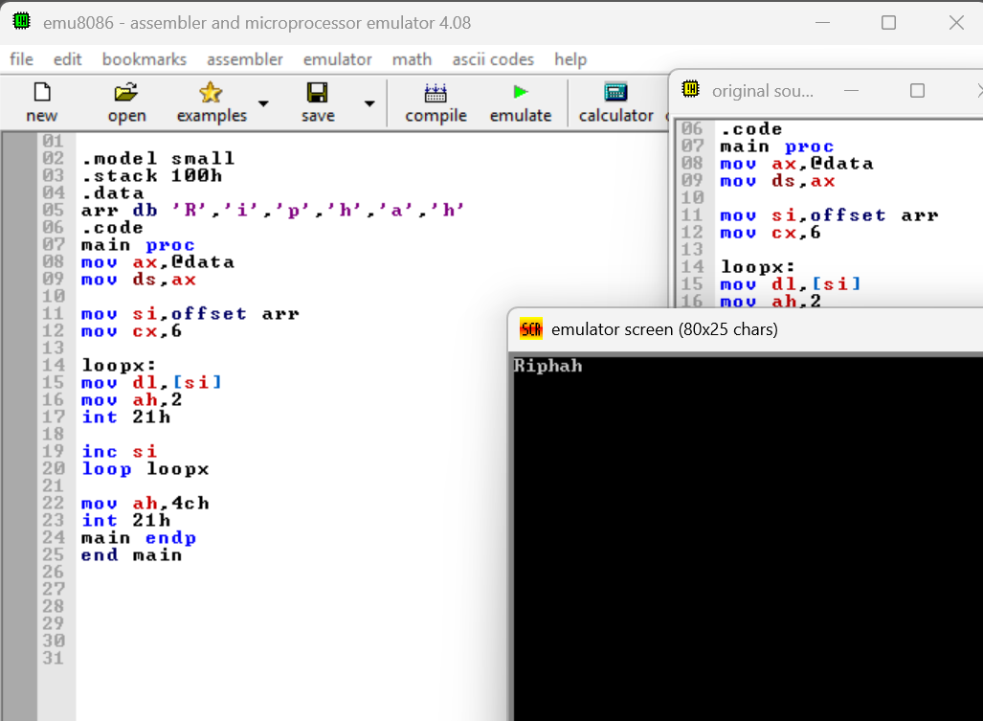

Task 02
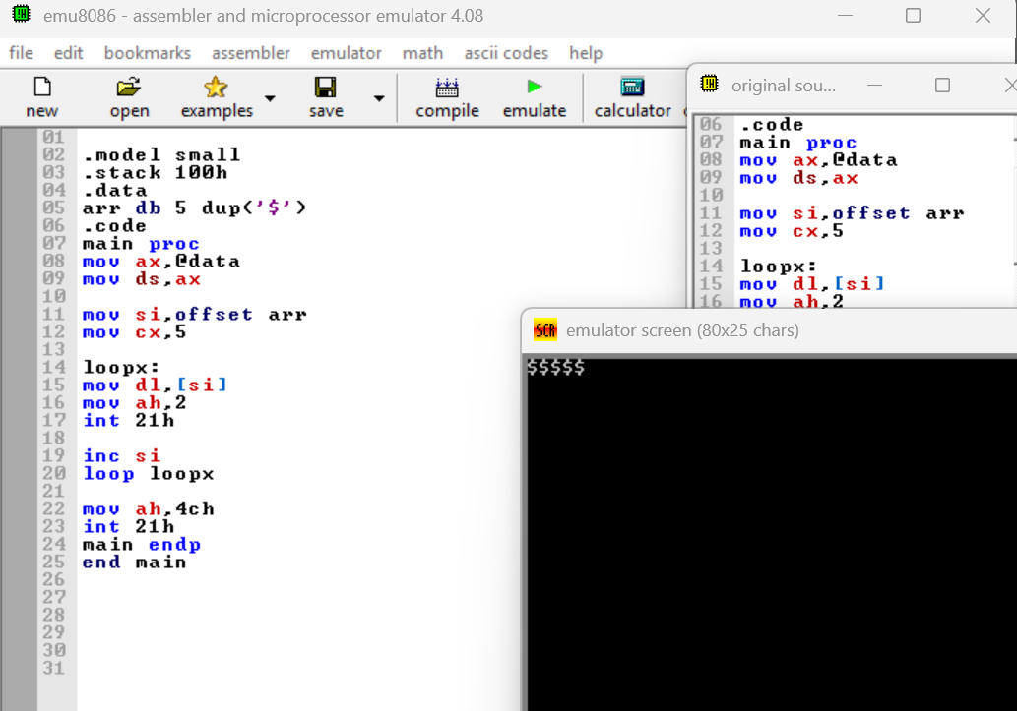

Task 03
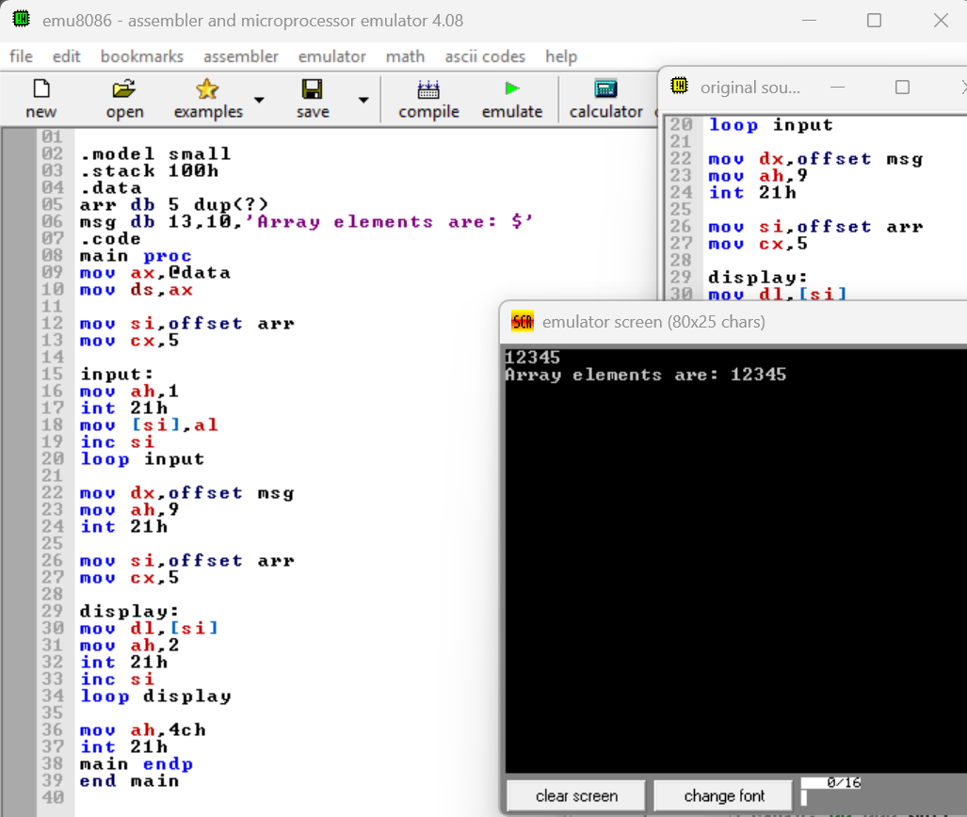

Task 04
Variable | Array
A variable stores a single value at a time. | An array stores multiple values under one name.
It is used to store individual data. | It is used to store a collection of data.
A variable has one memory location for its value. | An array uses consecutive memory locations for its elements.
It is accessed directly by its name. | Its elements can be accessed using an index or address.
Loops are not necessary to access a single variable. | Loops are commonly used to access array elements.
Example: A DB 5 | Example: ARR DB 1,2,3,4,5

